Test Case: tc002_SPX_Dev5_Crear_Requisicion_Spot_Con_FAD_Tipo_Cobro_CC
Step 1 - Enter username and password and click to button Enter : Credentials Entered
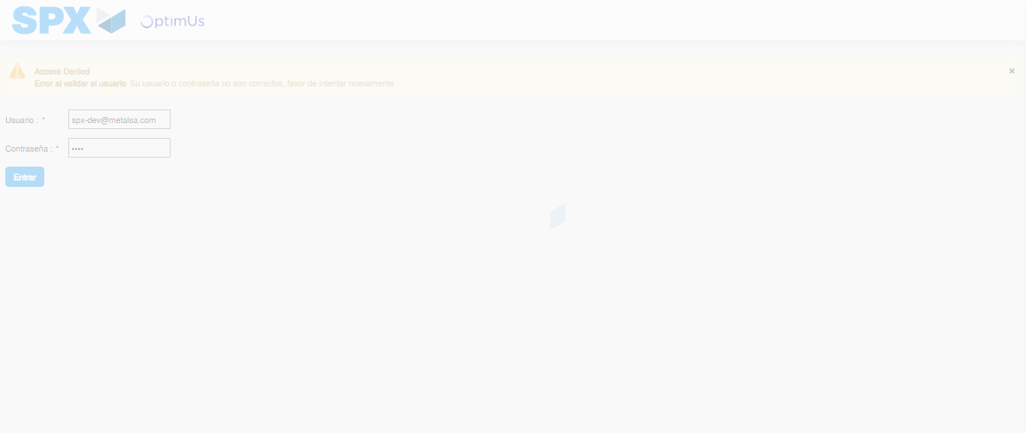Image file-name: QC_Testing-tc002_SPX_Dev5_Crear_Requisicion_Spot_Con_FAD_Tipo_Cobro_CC-1789483650824

Step 2 - Select to UEN and Access to Spot Buy Requisitions : UEN Correctly selected and Correct access
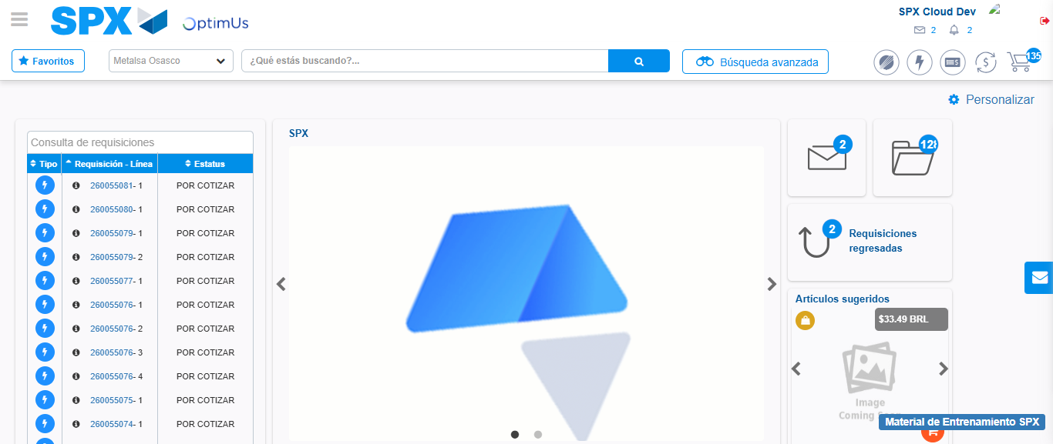Image file-name: QC_Testing-tc002_SPX_Dev5_Crear_Requisicion_Spot_Con_FAD_Tipo_Cobro_CC-1789483679087

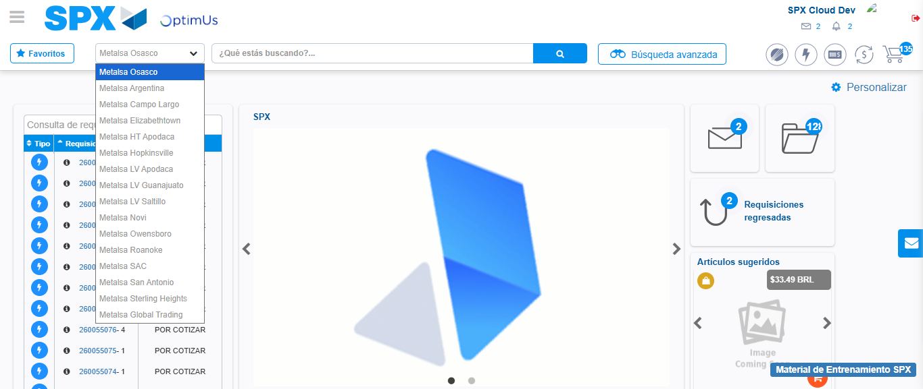Image file-name: QC_Testing-tc002_SPX_Dev5_Crear_Requisicion_Spot_Con_FAD_Tipo_Cobro_CC-1789483679588

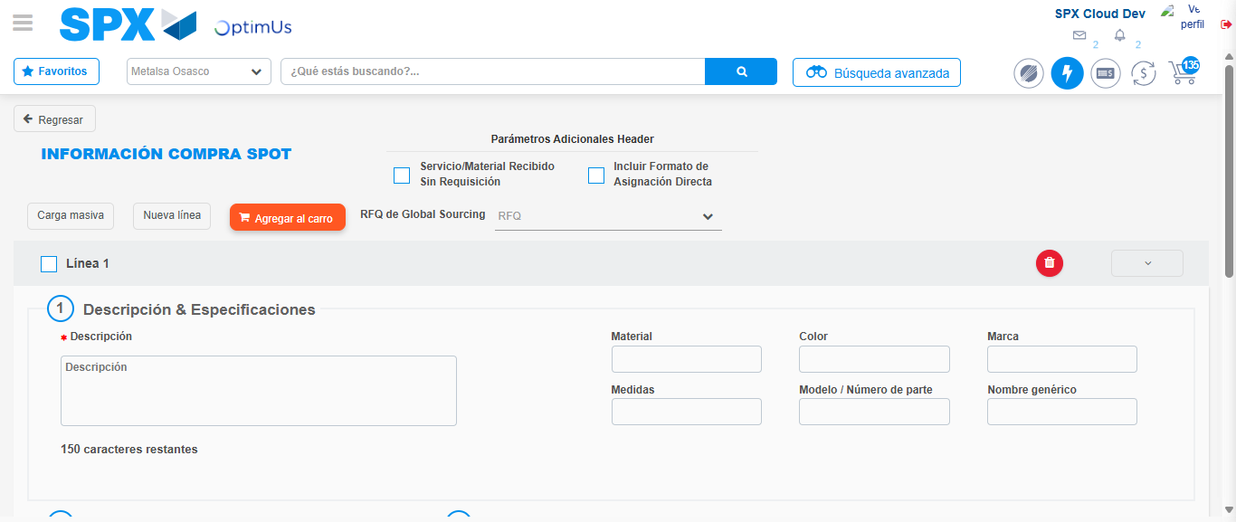Image file-name: QC_Testing-tc002_SPX_Dev5_Crear_Requisicion_Spot_Con_FAD_Tipo_Cobro_CC-1789483683402

Step 3 - Add FAD to Requisition: FAD Successfully Added
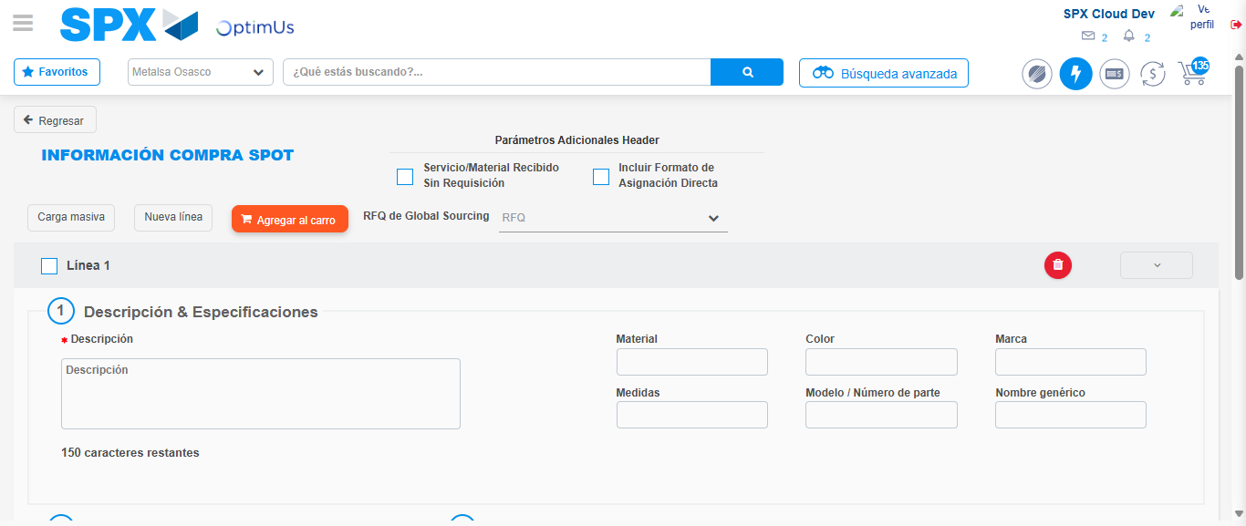Image file-name: QC_Testing-tc002_SPX_Dev5_Crear_Requisicion_Spot_Con_FAD_Tipo_Cobro_CC-1789483683705

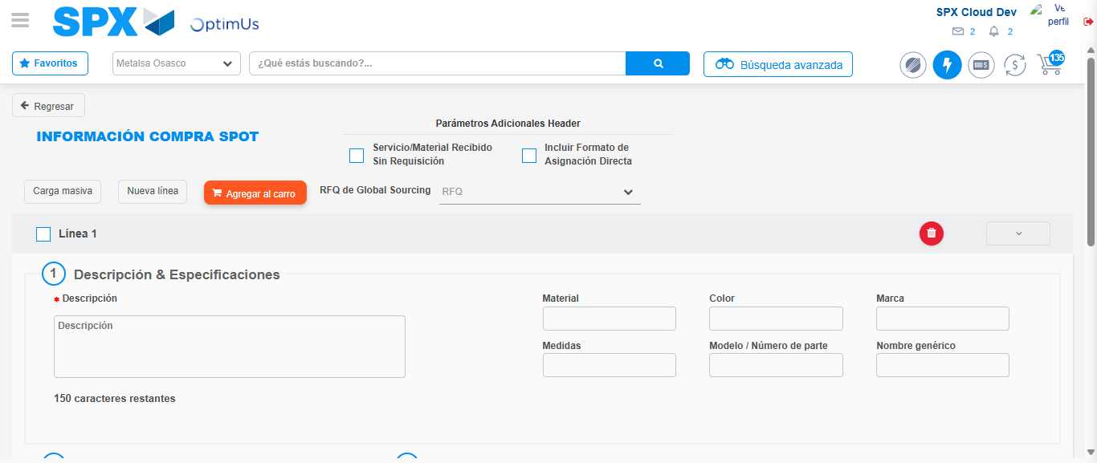Image file-name: QC_Testing-tc002_SPX_Dev5_Crear_Requisicion_Spot_Con_FAD_Tipo_Cobro_CC-1789483683916

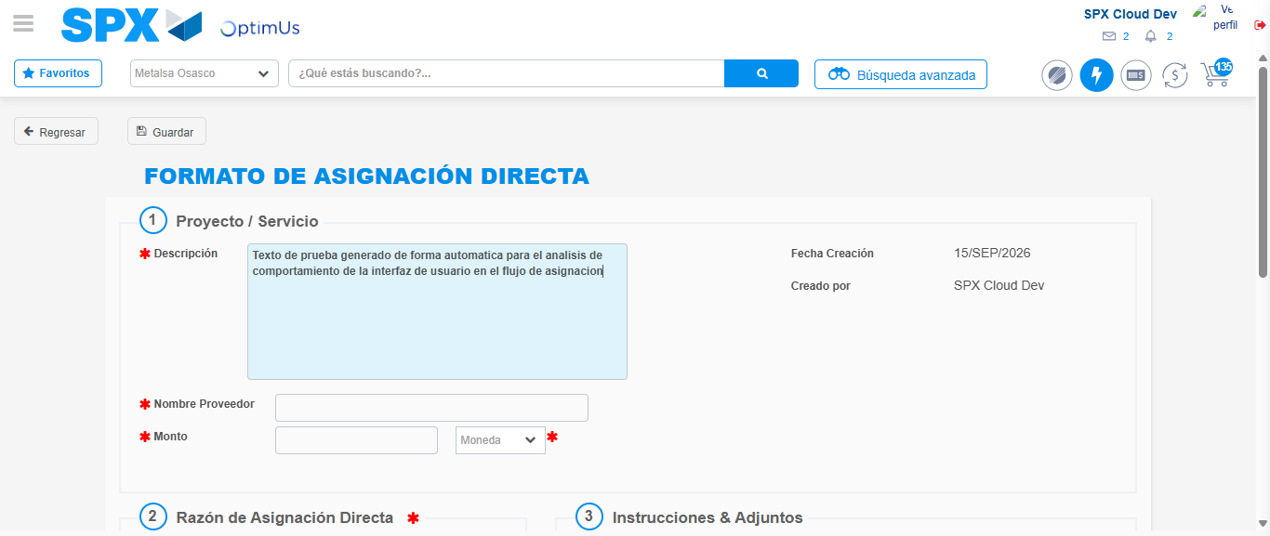Image file-name: QC_Testing-tc002_SPX_Dev5_Crear_Requisicion_Spot_Con_FAD_Tipo_Cobro_CC-1789483686587

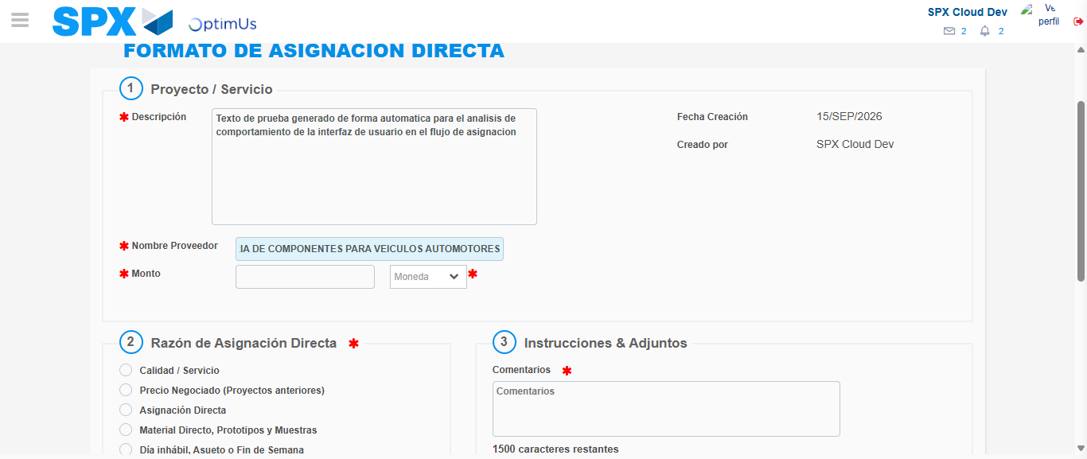Image file-name: QC_Testing-tc002_SPX_Dev5_Crear_Requisicion_Spot_Con_FAD_Tipo_Cobro_CC-1789483695353

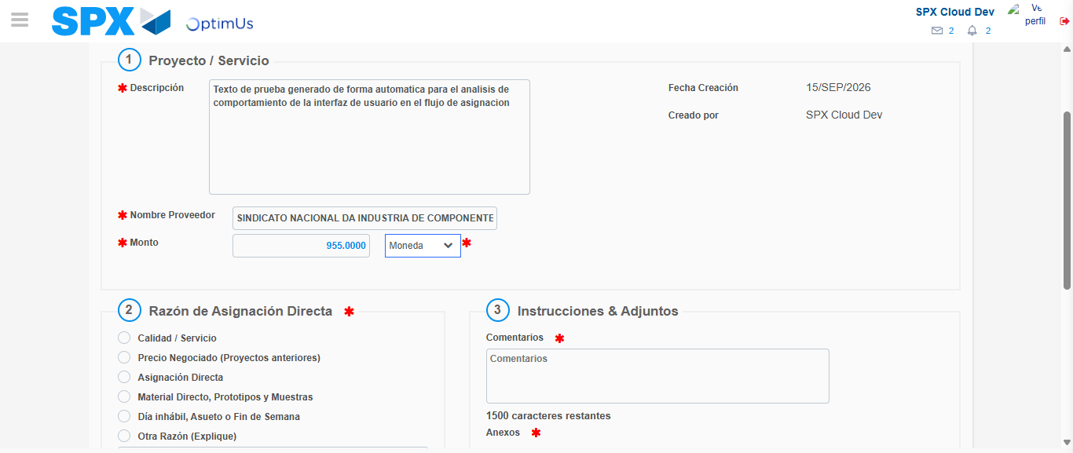Image file-name: QC_Testing-tc002_SPX_Dev5_Crear_Requisicion_Spot_Con_FAD_Tipo_Cobro_CC-1789483695789

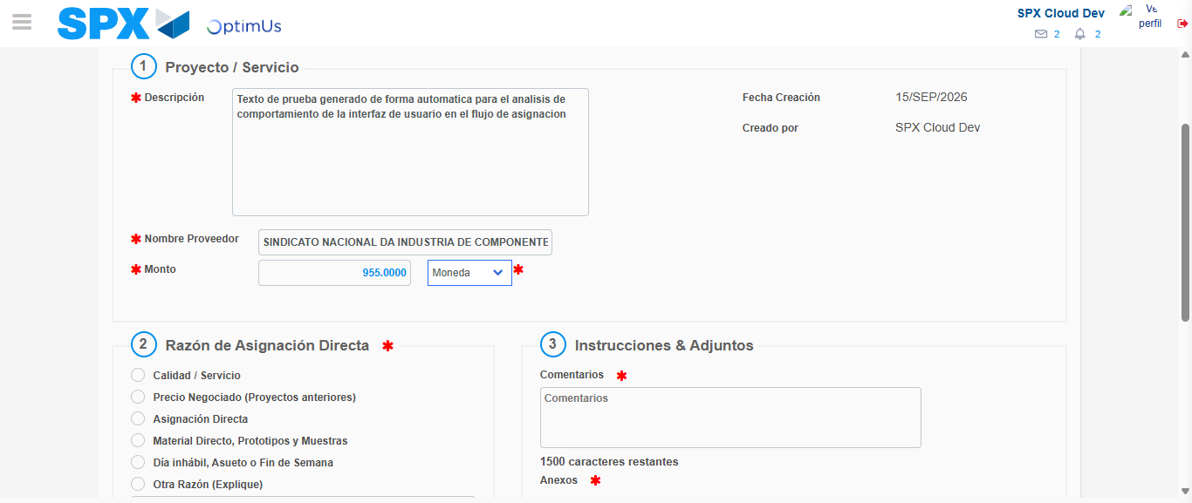Image file-name: QC_Testing-tc002_SPX_Dev5_Crear_Requisicion_Spot_Con_FAD_Tipo_Cobro_CC-1789483695988

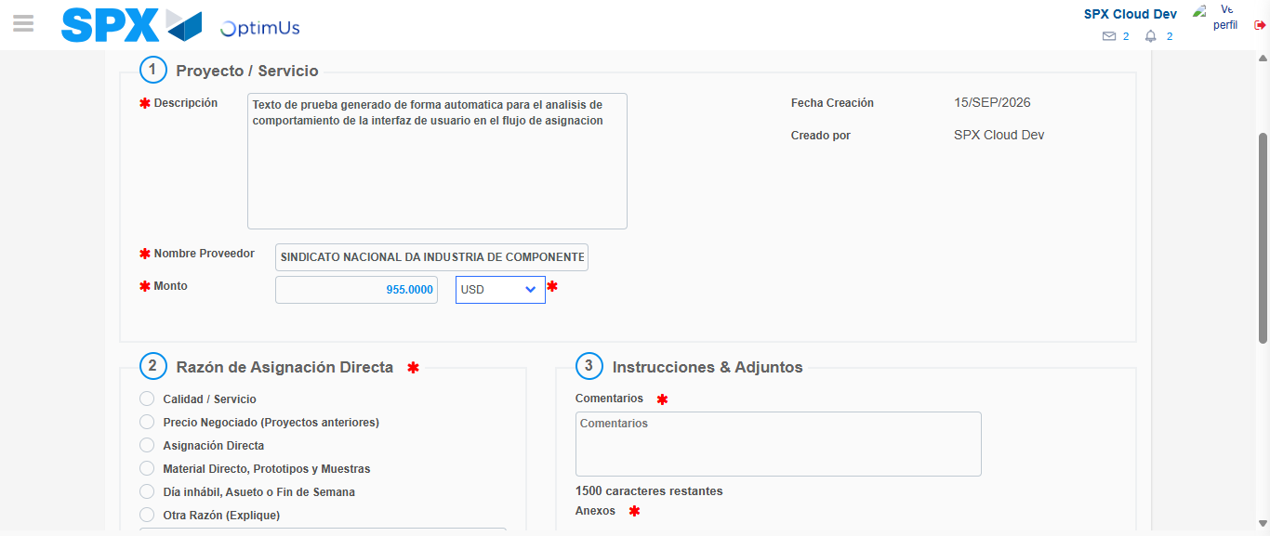Image file-name: QC_Testing-tc002_SPX_Dev5_Crear_Requisicion_Spot_Con_FAD_Tipo_Cobro_CC-1789483696307

Image file-name: QC_Testing-tc002_SPX_Dev5_Crear_Requisicion_Spot_Con_FAD_Tipo_Cobro_CC-1789483696493

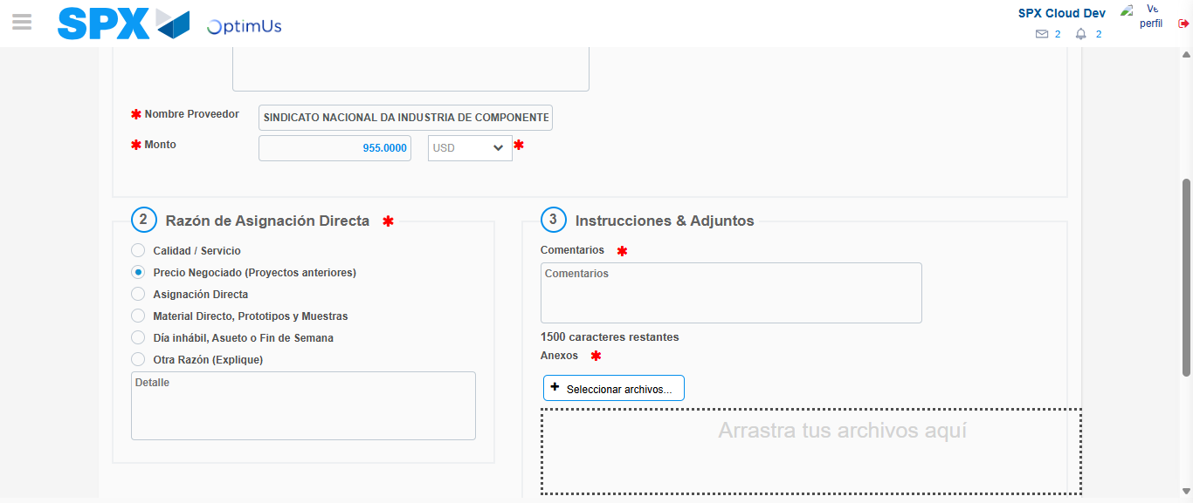Image file-name: QC_Testing-tc002_SPX_Dev5_Crear_Requisicion_Spot_Con_FAD_Tipo_Cobro_CC-1789483697302

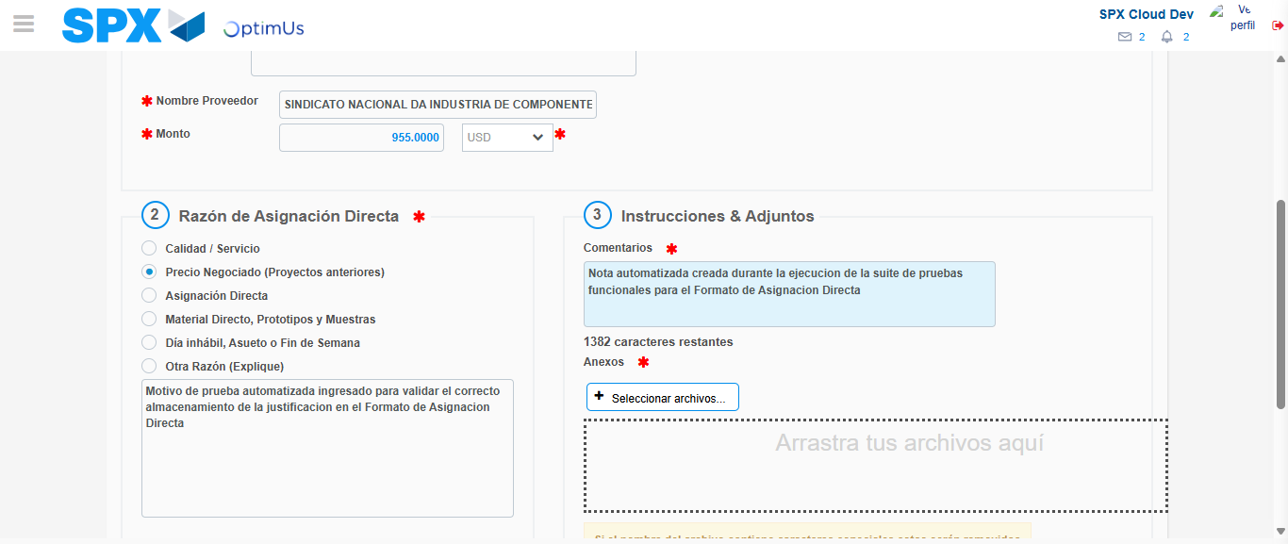Image file-name: QC_Testing-tc002_SPX_Dev5_Crear_Requisicion_Spot_Con_FAD_Tipo_Cobro_CC-1789483708358

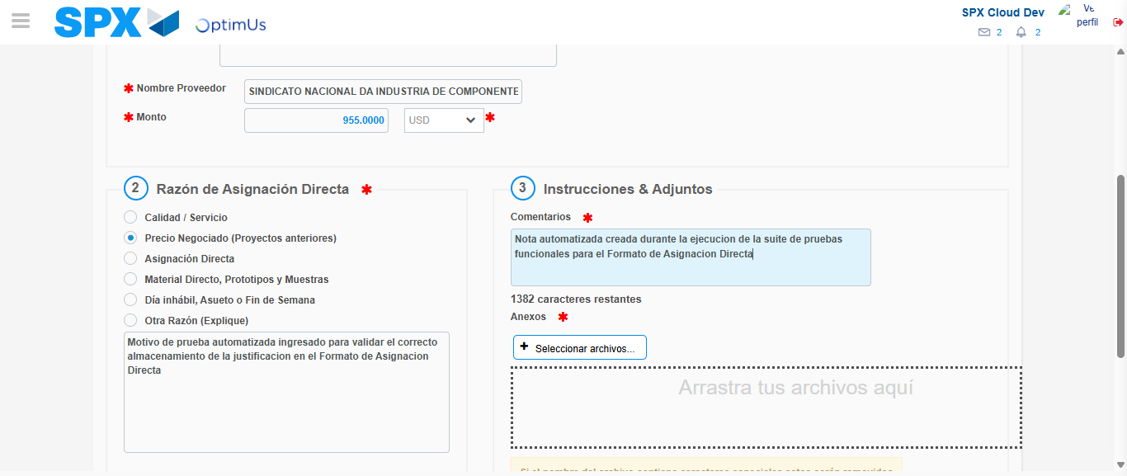Image file-name: QC_Testing-tc002_SPX_Dev5_Crear_Requisicion_Spot_Con_FAD_Tipo_Cobro_CC-1789483708926

Step 4 - Data Capture Spot Buy Requisition: Data captured correctly
Image file-name: QC_Testing-tc002_SPX_Dev5_Crear_Requisicion_Spot_Con_FAD_Tipo_Cobro_CC-1789483683705

Image file-name: QC_Testing-tc002_SPX_Dev5_Crear_Requisicion_Spot_Con_FAD_Tipo_Cobro_CC-1789483683916

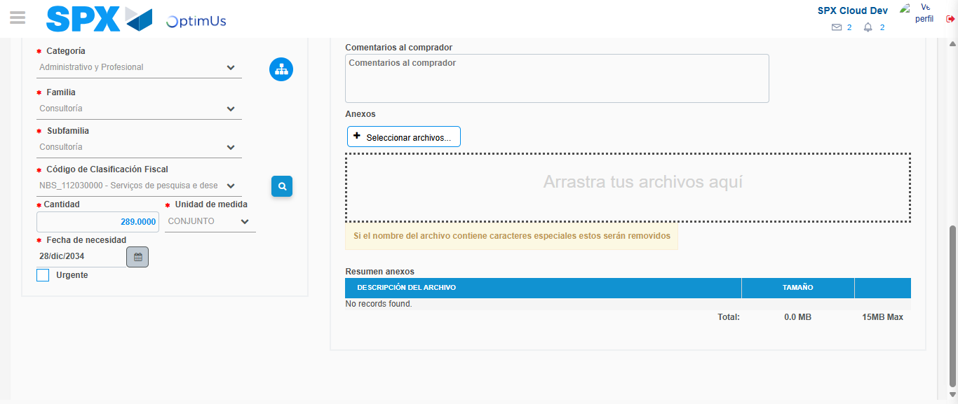Image file-name: QC_Testing-tc002_SPX_Dev5_Crear_Requisicion_Spot_Con_FAD_Tipo_Cobro_CC-1789483725058

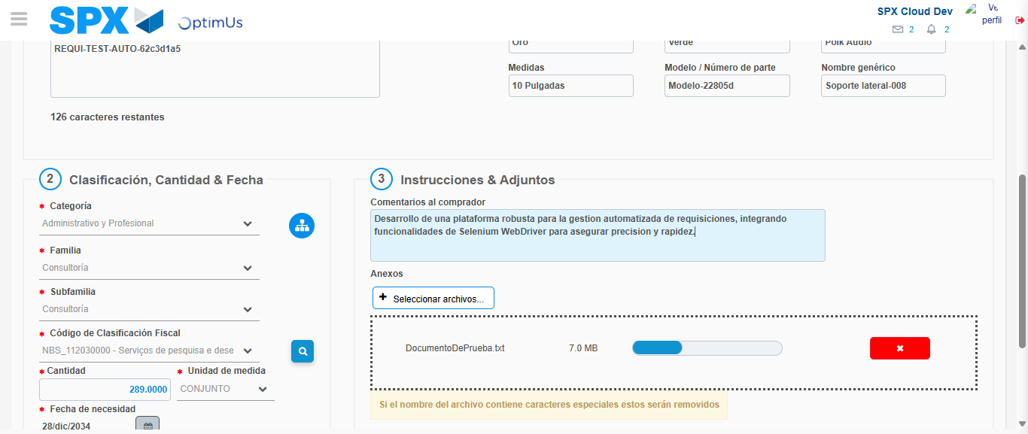Image file-name: QC_Testing-tc002_SPX_Dev5_Crear_Requisicion_Spot_Con_FAD_Tipo_Cobro_CC-1789483725768

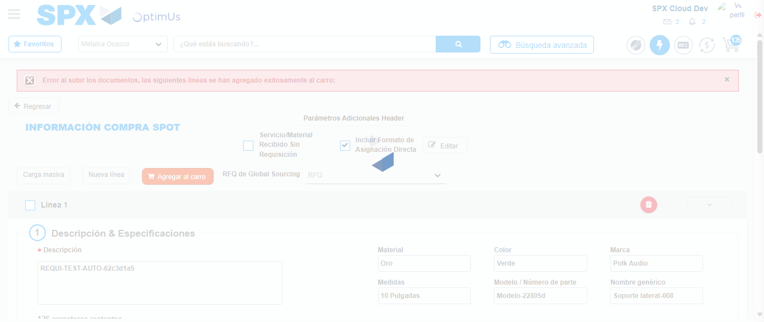Image file-name: QC_Testing-tc002_SPX_Dev5_Crear_Requisicion_Spot_Con_FAD_Tipo_Cobro_CC-1789483737567

Step 8 - Return to Main Page SPX : Return to Main Page SPX
Image file-name: QC_Testing-tc002_SPX_Dev5_Crear_Requisicion_Spot_Con_FAD_Tipo_Cobro_CC-1789483679087

Image file-name: QC_Testing-tc002_SPX_Dev5_Crear_Requisicion_Spot_Con_FAD_Tipo_Cobro_CC-1789483679588

Image file-name: QC_Testing-tc002_SPX_Dev5_Crear_Requisicion_Spot_Con_FAD_Tipo_Cobro_CC-1789483683402

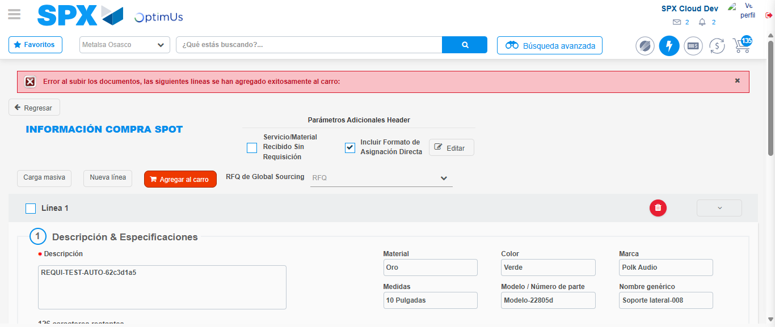Image file-name: QC_Testing-tc002_SPX_Dev5_Crear_Requisicion_Spot_Con_FAD_Tipo_Cobro_CC-1789483739877

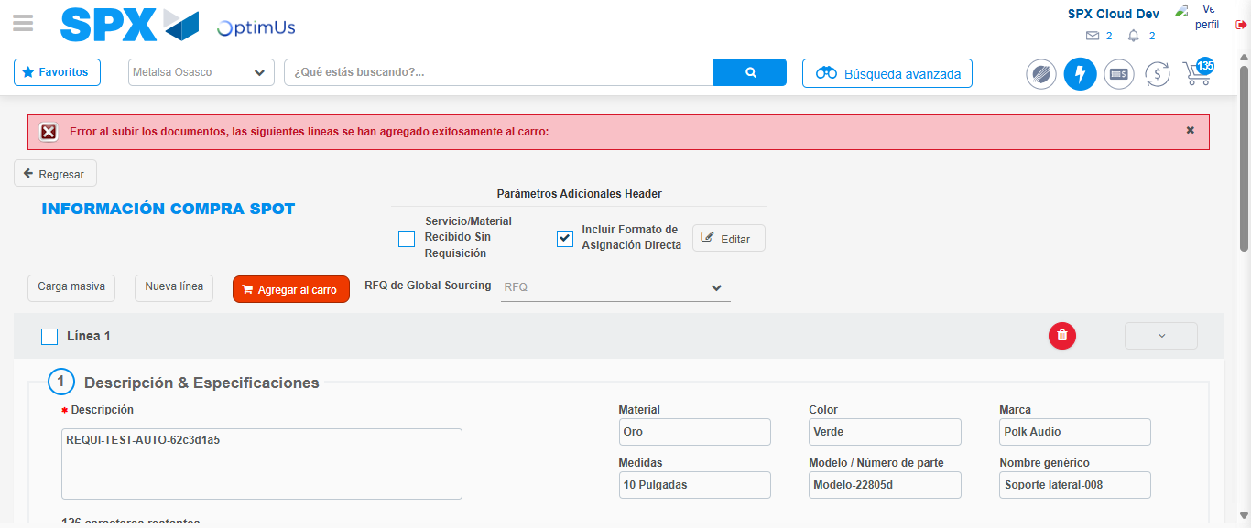Image file-name: QC_Testing-tc002_SPX_Dev5_Crear_Requisicion_Spot_Con_FAD_Tipo_Cobro_CC-1789483740075

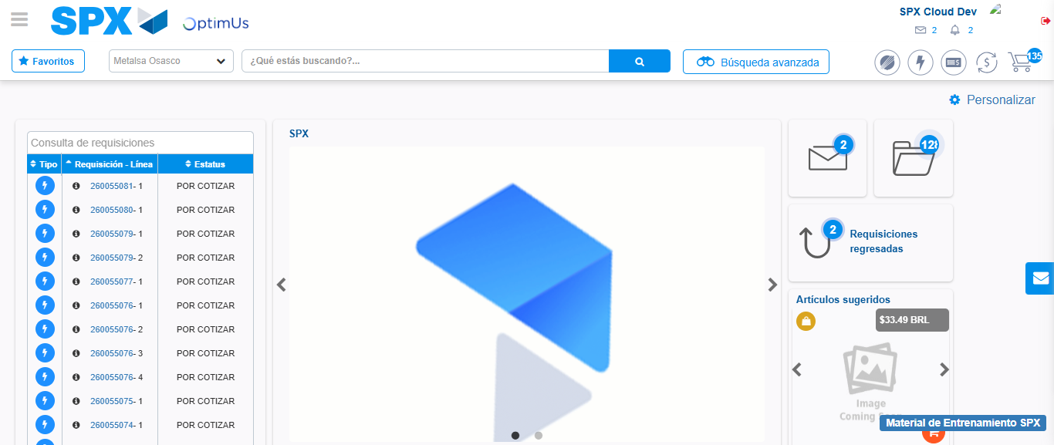Image file-name: QC_Testing-tc002_SPX_Dev5_Crear_Requisicion_Spot_Con_FAD_Tipo_Cobro_CC-1789483761350

Step 9 - Log Out : Log Out SPX
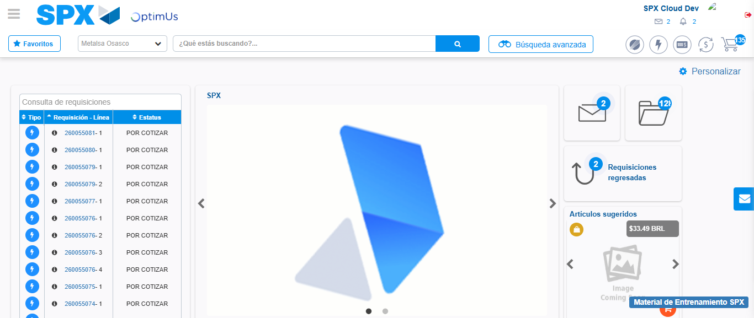Image file-name: QC_Testing-tc002_SPX_Dev5_Crear_Requisicion_Spot_Con_FAD_Tipo_Cobro_CC-1789483761640

